2024 NCBFAA Annual Scholarship Program Rules
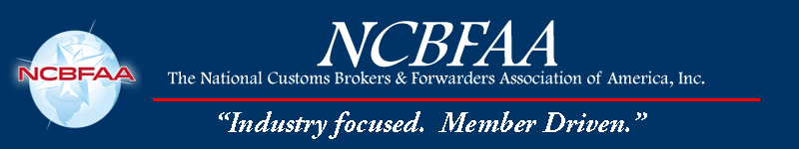
The 2024 NCBFAA Annual Scholarship program is open to any Regular Member employee or a child of a Regular Member employee who is pursuing an undergraduate or graduate degree at an accredited U.S. college or university for their professional advancement in our industry. These scholarships demonstrate the commitment of the Sponsors and the NCBFAA to continuing education in our ever-changing industry.

Two scholarships ($5,000 each) will be paid directly to the institution in the name of the
awardee(s).

The scholarship awardees will also be invited to the 51st NCBFAA Annual Conference at the Fort Lauderdale Marriott Harbor Beach Resort and Spa in Fort Lauderdale, Florida, on April 14-17, 2024, and will join the other conference attendees during lunch on April 15 to receive the Award, which will be paid directly to the student's college or university.

Criteria for Eligibility

- Applicants must be currently enrolled and pursuing either an undergraduate or graduate degree in industry-related studies at an accredited U.S. college or university.
- Complete a 1,000-2,000-word typed, double-spaced essay, along with detailed bibliography, on the international trade topic selected by the NCBFAA Scholarship Committee.
- Provide an employment verification letter from NCBFAA regular member firm indicating that the candidate is employed, or the child of a parent or legal guardian employed with the Regular Member firm.
- Provide proof of acceptance or current enrollment in an accredited college or university, your class year (e.g., undergraduate freshman, sophomore, etc.), and major area of study.
- Include a short (100 words or less) personal statement on your career goals.

Selection Process

All applications, which include completed essays, must be submitted to NCBFAA by Thursday, Feb. 29, 2024.

Send to:

2024 NCBFAA Scholarship
8601 Georgia Avenue, # 612
Silver Spring, Maryland 20910

Or by email to: cgillis@ncbfaa.org

The NCBFAA Scholarship Committee will select the winners and announce the awards by the second week in March 2024. The awardees will be notified by e-mail. NCBFAA will cover the cost of the roundtrip flight and one night stay for the individual awardees to be recognized during the 51st NCBFAA Annual Conference at the Fort Lauderdale Marriott Harbor Beach Resort and Spa in Fort Lauderdale, Florida, on April 14-17, 2024.

If you have any questions concerning the scholarship, please email Christopher Gillis at cgillis@ncbfaa.org.

