Here's how to earn a $5,000 scholarship! *
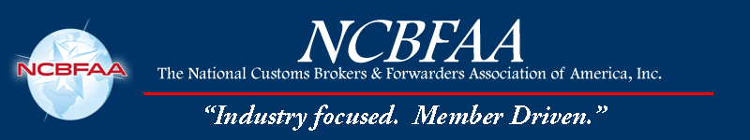
To compete for this award, you must:
- Write an essay and a personal statement (see details below).
- Be an employee or child of an employee with a NCBFAA Regular Member, but not own a company involved in the industry.
- Be pursuing a career in customs brokerage, freight forwarding, or a related field in international trade.
- Be a senior in high school, undergraduate, or graduate student enrolled at an accredited college or university.
- Previous winners are not eligible for consideration.
- Follow the instructions below and submit this entry form with required attachments to NCBFAA.
GOOD LUCK!

*Paid directly to recipient's college or university.

Name

Street Address or PO Box

City/State/Zip

Phone Cell Fax Email

If my essay wins the competition, I authorize the NCBFAA to use it for marketing purposes, including posting it on their website and the sponsor’s website. Initial ______

Name of NCBFAA Regular Member firm under which you qualify

Your relationship to NCBFAA Regular Member firm

Attach the following:
- 1,000-2,000-word typed, double-spaced essay, along with detailed bibliography, on the topic “What are the key steps an organization should take to ensure that training, auditing, and engagement with a licensed customs broker and the sharing of industry information are effectively relayed to all employees, as well as properly documented to substantiate compliance with the updated customs broker regulations per 19 CFR 111.28?”
- Employment verification letter from NCBFAA Regular Member firm indicating that the candidate is employed or a family member of an employee with a Regular Member firm.
- Proof of acceptance to or current enrollment in an accredited college or university, your class year, and major area of study.
- Short (100 words or less) personal statement on your career goals.

Complete this application and mail to:
2024 NCBFAA Scholarship
8601 Georgia Avenue, # 612
Silver Spring, Maryland 20910

Or by email to: cgillis@ncbfaa.org

All applications must be received
by Thursday, Feb. 29, 2024

